Ideation Phase
Empathize & Discover

Date | 01 NOV 2025
Team ID | NM2025TMID02455
Project Name | Medical Inventory Managemen
Maximum Marks | 4 Marks

Empathy Map Canvas:
In the Empathize & Discover phase, the team observes how pharmacists, nurses, and hospital admins handle medical inventory on a daily basis. They notice that users often feel frustrated and stressed due to inaccurate stock data, missing supplies, and a lack of expiry alerts. Through interviews and observations, the team learns that these issues lead to treatment delays, workflow interruptions, and wasted medical resources. Staff frequently spend extra time searching for items or manually verifying stock levels, which affects both efficiency and patient care.
By gathering these insights, the team gains a deeper understanding of how poor inventory systems impact daily operations, safety, and staff confidence. They realize that users need real-time inventory tracking, automated notifications for low or expired stock, and clearer visibility of supply locations. These discoveries emphasize the importance of designing a user-friendly, intelligent system that minimizes manual effort, improves accuracy, and ensures uninterrupted healthcare delivery.
Example:
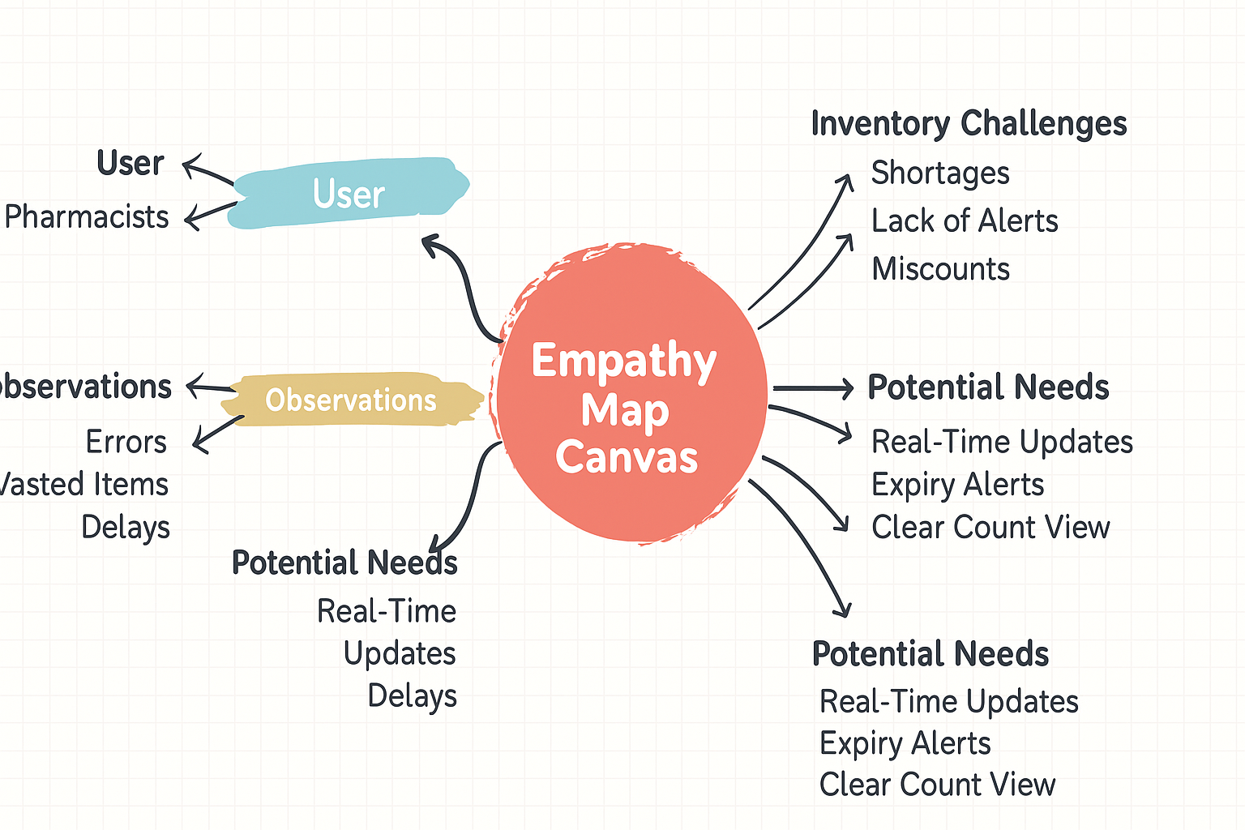

The empathy map helped us understand users’ struggles with inaccurate stock data, missing supplies, and expired items.
It revealed their need for real-time updates, automated alerts, and better visibility of inventory.
These insights guided us to design a smarter system that ensures accuracy, efficiency, and patient safety.
Example: “Healthcare Supply Management Application”
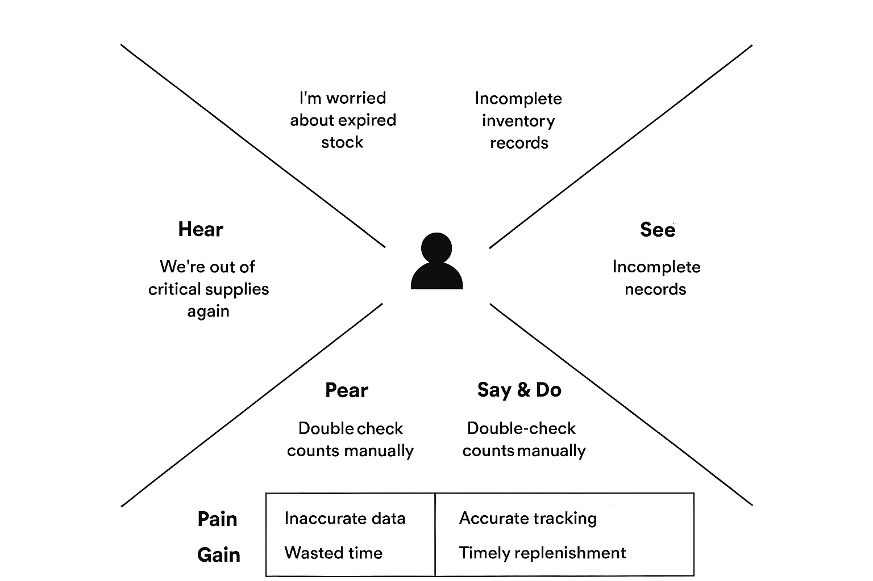

By deeply understanding users through empathy mapping, we uncovered the main frustrations and risks in managing medical inventory. The map highlighted issues such as inaccurate stock data, missing or expired supplies, and the need for real-time visibility. These insights guided the design of a smarter inventory management system with automated alerts, expiry notifications, and real-time tracking. As a result, the solution minimizes errors, ensures timely replenishment, and enhances efficiency and confidence in healthcare operations.

